Gramática Livre de Contexto Sem Forma Normal:
$$E→E+T\left|E-T\right|T$$
$$T→T*F \left|T/F\right| F$$
$$F→P^F | P$$
$$P→ -U| U$$
$$U→\left(E\right)|N$$
$$N→ND|D$$
$$D→{\left[0-9\right]}^{+}$$

Árvore De Expansão:
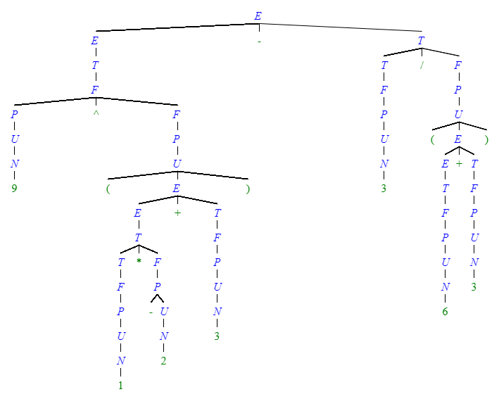

Gramática Livre de Contexto na forma normal de Chomsky:
$$E→EX_{1} \left| TX_{2} \right| PX_{3} | C_{sub}U \left|{ C}_{pe}X_{4} \right| ND \left| 0 \right| 1 \left| 2 \right| 3 \left| 4 \right| 5 \left| 6 \right| 7 \left| 8 \right|9$$
$$T→TX_{2} | PX_{3} | C_{sub}U \left|{ C}_{pe}X_{4} \right| ND \left| 0 \right| 1 \left| 2 \right| 3 \left| 4 \right| 5 \left| 6 \right| 7 \left| 8 \right|9$$
$$F→PX_{3} | C_{sub}U \left|{ C}_{pe}X_{4} \right| ND \left| 0 \right| 1 \left| 2 \right| 3 \left| 4 \right| 5 \left| 6 \right| 7 \left| 8 \right|9$$
$$P→C_{sub}U \left|{ C}_{pe}X_{4} \right| ND \left| 0 \right| 1 \left| 2 \right| 3 \left| 4 \right| 5 \left| 6 \right| 7 \left| 8 \right|9$$
$$U→C_{pe}X_{4} \left| ND \right| 0 \left| 1 \right| 2 \left| 3 \right| 4 \left| 5 \right| 6 \left| 7 \right| 8 | 9$$
$$N→ND \left| 0 \right| 1 \left| 2 \right| 3 \left| 4 \right| 5 \left| 6 \right| 7 \left| 8 \right| 9$$
$$D→ 0 \left| 1 \right| 2 \left| 3 \right| 4 \left| 5 \right| 6 \left| 7 \right| 8 | 9$$

$$X_{1}→C_{Soma}T | C_{sub}T$$
$$X_{2}→C_{Mult}F | C_{div}F$$
$$X_{3}→C_{Exp}F$$
$$X_{4}→EC_{pd}$$
$$C_{soma}→+$$
$$C_{sub}→-$$
$$C_{mult}→ *$$
$$C_{div}→ /$$
$$C_{Exp} →^$$
$$C_{pe}→($$
$$C_{pd}→)$$
Árvore de Expansão:
